**SAMPLING FISH AND MACROINVERTEBRATE**

**RESOURCES IN TIDAL WETLANDS**

**SACRAMENTO-SAN JOAQUIN DELTA**

**Report on**

**PHASE IV PILOT MONITORING IN 2018**

Dave Contreras, Daniel Ellis, Rosemary Hartman, and Stacy Sherman

Fish Restoration Program Monitoring Team

California Department of Fish and Wildlife

Stockton, California

Draft

Contents

Preface 3

Pilot Monitoring Phases 4

Project Objectives 4

Part 1: Phytoplankton and Invertebrate spatial and temporal variability 5

Introduction 5

Methods 6

Sampling Sites 6

Habitat Types and Sampling gears 10

Laboratory Methods 15

Analysis 16

Results 19

Discussion 19

Chapter 2: Channel-Shoal Gear Comparison 19

Introduction 19

Nutrients 19

Zooplankton 19

Fish 20

Methods 20

IEP Surveys 20

FRP Sampling 21

Lab methods 25

Analysis 25

Results 27

Discussion 27

CHAPTER 3: Methods Development 27

Introduction 27

ARIS Sonar 27

SAV methods devlopment 27

Methods 27

Location and Timing 27

Description of Sampling Methods 29

ARIS Evaluation of Boat Electrofisher and Gill Net 29

SAV survey techniques 29

Analysis 29

Results 30

Discussion 30

Endangered Species Act Take 40

Data Management and Distribution 41

Reports 41

Publications and Conferences 42

References 43

# Preface

Much of the tidal wetland restoration in the Sacramento-San Joaquin Delta and Suisun Marsh (the Upper SF Estuary) is being constructed under the premise that wetland restoration will increase the resilience of threatened fish. The Fish Restoration Program Monitoring Team (FRP) is tasked with developing monitoring plans for tidal wetland sites restored pursuant to requirements in the 2008/2009 Biological Opinions for state and federal water project operations (USFWS 2008, NMFS 2009, CDFW 2009). We led the Interagency Ecological Program (IEP) Tidal Wetlands Monitoring Project Work Team (PWT) in developing the Tidalwetland monitoring framework for the upper San Francisco Estuary (hereafter "Framework"; PWT 2017a). The PWT has developed a set of conceptual models and hypotheses for how wetlands benefit fish (Sherman et al. 2017). These were the basis for recommendations for sampling methods to evaluate effectiveness of restoration projects (PWT 2017b). FRP has rigorously tested these sampling methods, but questions remain as to the comparibilty of FRP data, collected in wetlands, and long-term IEP monitoring data, collected in channels.

FRP monintoring takes a whole-ecosystem approach for describing the capacity, opportunity, and realized function (sensu Simenstad XXX) provided by wetland restoration to at-risk fishes.

Meso- and macroinvertebrates, including amphipods, mysids, insects, copepods and isopods, are important food resources for tidal wetland fish, but are often patchily distributed and highly variable (Slater and Baxter 2014, Whitley and Bollens 2014, Baxter et al. 2015, David et al. 2016). Monitoring

The spatial and temporal variability inherent in these taxa make them difficult to monitor. While we have already tested several monitoring methods for these groups of invertebrates, monitoring change over time requires understanding the level of spatial and temporal replication necessary for statistical validity. Information on meso- and macroinvertebrates is necessary to address framework hypotheses F2-F5, which were derived from the PWT’s Food Web Conceptual Model (Secondary Production tier, Hartman et al., In Press) and Chinook Salmon Tidal Wetland Model (Environmental Drivers and Habitat Attributes tiers, Goertler et al. In Press).

Even for established methods, such as zooplankton trawls, more research is needed to determine the spatial and temporal extent of inference that can be made for a given metric. Multiple long-term monitoring surveys sample the pelagic realm for zooplankton using well-established methods (Hennessy et al. 2009). However, it is unclear the extent to which zooplankton communities differ between the deep channel habitat currently sampled and the wetlands that our program will sample (Kimmerer et al. 1998, 2002; Bollens et al. 2014). Understanding differences in communities between channels and wetlands is also necessary to detect exchange between these habitats that is predicted to increase food availability in the channel (Framework hypotheses F8-F10, Hartman et al., in In Press).

Fish are also highly variable across the Upper SF Estuary. Although fishes ranging from larvae to adults are sampled regularly, just a few sampling programs focus on small channel/shallow water/vegetation edge habitats. We have tested several different types of gear for catching fish in these habitats in the North Delta (Cache Slough Region). We need a better understanding of the function of these gears across estuarine gradients and how catches compare to long-term IEP monitoring. Fish community sampling in long-term monitoring is needed to determine the presence of listed species (hypotheses P4 and P14), to provide specimens of listed fish for various potential studies of diet, condition, and growth (hypotheses F4-F7), and to understand the potential for predation on and competition with the listed species (hypothesis S4), aspects of “capacity” in the Habitat Attributes tier of the Chinook Salmon Tidal Wetlands conceptual model (Goertler et al., In Press).

## Pilot Monitoring Phases

We conducted a Phase I “gear exploration” from July to October 2015 (Contreras et al. 2016). Based on results from that effort, successful methods were selected for inclusion in the second phase of pilot work. Phase II occurred from February through July 2016, and provided a more rigorous evaluation of gear feasibility during the time of year listed fish are most likely to be using wetlands (Contreras et al. 2017). Phase II included quantitative comparisons of abundance, size, composition, and diversity which led to recommended gear types. The recommended gear types from Phase II were used in the Phase III study that further refined the spatial and temporal sampling schemes necessary to evaluate monitoring hypotheses, and began testing the extent to which IEP’s channel-based monitoring surveys can be used to make inferences on tidal wetlands.

After each pilot phase, results were reviewed by the PWT before inclusion in development of plans for the next phase. This report covers Phase IV, which expanded comparisons between FRP and IEP surveys, tested new methods for monitoring fish, SAV, nutrients, and phytoplankton, and began collecting pre-project data at future restoration sites.

## Project Objectives

* Determine the extent to which long-term IEP sampling reflects conditions in nearby shallow-water and wetland habitats.
* Determine whether gear efficiency evaluations are feasible using new sampling technology (i.e., ARIS sonar).
* Determine the level of spatial and temporal replication necessary to make sampling design recommendations for long-term monitoring.
* Begin developing a baseline of biomass, community composition, and fish condition for fish and invertebrates near planned tidal restoration and comparison sites. This will allow us to make pre-and-post-restoration comparisons for evaluating restoration progress.

## 

# Part 1: Phytoplankton and Invertebrate spatial and temporal variability

## Introduction

### Invertebrates

Understanding the variability of zooplankton and macroinvertebrates will allow us to evaluate appropriate timing and replication of samples for characterizing macroinvertebrate communities that provide fish food in restored tidal wetlands. Macroinvertebrates associated with vegetation and shallow water habitat, such as amphipods and insect larvae, have been historically under-studied in this system; however, they provide the majority of salmonid diet composition in these areas (Bottom et al. 2011; David et al. 2016; Maier and Simenstad 2009; Sommer et al. 2001), and are a component of Delta Smelt diets when smelt occur in areas of high macrophyte production (Whitley and Bollens 2014). Because these groups are understudied, it is unclear how variable biomass and community composition are within a site, between sites and between seasons. Because epifaunal invertebrates are a smaller percentage of smelt diets (Slater and Baxter 2014) and are less mobile than zooplankton, it may only be necessary to sample these macroinvertebrates once or twice per year. If sampling is limited, we want to determine what time of year has greatest overlap between listed fish species and their food supply.

We chose spring for our spatially intensive sampling, because this is when there is the highest density of juvenile salmonids rearing in the estuary (Williams 2012), Delta Smelt are spawning in the freshwater Delta (Baxter et al. 2015; Sommer and Mejia 2013), and Longfin Smelt are present and spawning in the marshes surrounding Suisun Bay (Grimaldo et al. 2017). However, the importance of food supply during the fall, while juvenile smelt area rearing, is considered one of the major factors in population resilience (Baxter et al. 2015; Brown et al. 2014). Therefore, chose to characterize potential food supply in areas important to smelt in the fall.

Due to limited resources, we targeted fall sampling only in areas likely to have high smelt abundance. In most years, a majority of the population migrates to the Low Salinity Zone (LSZ), to rear (Baxter et al. 2015). This area generally stretches from Suisun Bay to the Confluence, though exact location depends on water year type (Brown et al. 2014). There is an additional resident population of Delta Smelt which remains in the North Delta year round (Sommer et al. 2009), so we chose to target these areas for additional fall sampling.

### Phytoplankton

Phytoplankton are considered to be one of the key carbon sources in the aquatic food web. However, not all phytoplankton are created equal. Diatoms and green algae are preferred over cyanobacteria and flagellates in most Cladocera and copepod species studied in this estuary (Orsi 1995), though more recent studies suggest cyanobacteria make up a large part of copepod diets when they occur in high abundance (Stephanie Owens, SFSU, pers. Comm.). Furthermore, preferred food differs by species of zooplankton and species of phytoplankton (Bouley and Kimmerer 2006; Cloern and Dufford 2005; Jassby 2008). In the past, most evidence pointed to pelagic phytoplankton as the key driver of the Bay-Delta food web (Canuel et al. 1995; Sobczak et al. 2005; Sobczak et al. 2002), however, more recent work suggests benthic, epiphytic, and wetland-derived carbon may plan a more important role than previously realized (Schroeter et al. 2015).

Given the importance of species identity when assessing phytoplankton’s role in the food web, we need some phytoplankton community monitoring on FRP sites. Once we start regular monitoring of restoration sites, we will take phytoplankton samples concurrently with monthly zooplankton samples. However, wanted to first establish a baseline of phytoplankton variability within the wetlands. Therefore, this year I want to collect phytoplankton concurrently with the “spring blitz” sampling of macroinvertebrates.

#### Study questions:

1. How do invertebrate and phytoplankton communities change from year to year?
2. Are there significant differences between channel habitat, managed wetlands (pre-restoration), and tidal wetlands (remnant and/or post-restoration)?
3. What food is available for listed fish species throughout the year?
   1. When during the spring is most important to sample?
   2. How do fall food resources compare to spring food resources?

## Methods

### Sampling Sites

To answer questions 1 and 2, we sampled FRP restoration sites and surrounding wetlands distributed across the Delta and Suisun Marsh FRP (Table 1, Figure 1). These sites incorporate varying salinity and surrounding land use (the “ecoclines” identified in the IEP TWM PWT conceptual models, see (Sherman et al. 2017)). Sites for 2018 were an expanded set of sites sampled in 2017, allowing for year-to-year comparisons. Sampling restoration sites (“Impact” sites) before restoration and comparing these sites to existing wetlands (“Control” sites) allows for a Before-After, Control-Impact design, once restoration is completed on some of these sites. While we do not expect our restoration sites to develop exactly like the comparison sites, the network of comparison sites provide a background, or “ambient” condition for the estuary that will allow us to better see the effectiveness of the restoration actions.

Note: We collected samples at Dow Wetlands in the spring of 2018, but we did not process the samples or analyze the data due to changes in priorities recommended by DWR FRP staff.

To answer question 3, we conducted increased sampling at one site (Decker Island) four times throughout the spring, and sampled in the fall at a subset of the locations where Delta Smelt are found most often. An analysis of data from the Fall Midwater Trawl Survey from September and October 2010-2016 showed the majority of the smelt caught where in the Confluence of the Sacramento and San Joaquin Rivers and Suisun Bay (CDFW data available: https://www.wildlife.ca.gov/Conservation/Delta/Fall-Midwater-Trawl). There is an additional, resident population in the Cache Slough Complex (Baxter et al. 2015), so we sampled the subset of wetland sites near these “smelt- hot- spots” during the fall (October 9th – November 1st), at a lower intensity than spring sampling. Before conducting the fall sampling, we assessed the data from the FMWT and the USFWS’s Enhanced Delta Smelt Monitoring (EDSM) survey to determine whether the fall 2018 smelt distribution matched previous years.

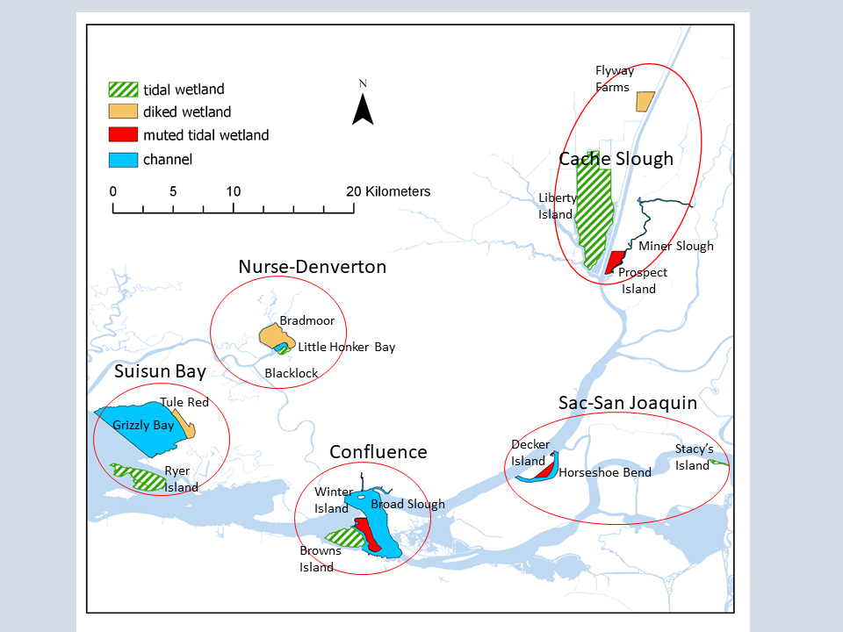

Figure Sites that were sampled during the spring of 2018. Within each region (outlined in red), we compared pre-project data from currently diked or muted tidal wetlands (planned restoration sites), with data from associated channel habitat, and existing tidal wetlands.

Table . Sample sizes for spring sampling in 2018. Sample numbers differ based on site size, habitat availability, and logistical constraints.

|  |  |  |  |  |  |  |  |  |
| --- | --- | --- | --- | --- | --- | --- | --- | --- |
| Site | Region | benthic grab | mysids | neuston | phytoplankton | Sweep net | Zooplankton | Total |
| Flyway Farms | Cache Slough Complex | 4 | 0 | 0 | 7 | 6 | 0 | 17 |
| Liberty Island | Cache Slough Complex | 6 | 9 | 6 | 17 | 8 | 9 | 55 |
| Miner Slough | Cache Slough Complex | 4 | 5 | 4 | 4 | 4 | 5 | 26 |
| Prospect Island | Cache Slough Complex | 2 | 3 | 1 | 5 | 9 | 8 | 28 |
| Broad Slough | Confluence | 4 | 5 | 6 | 5 | 5 | 6 | 31 |
| Browns Island | Confluence | 3 | 6 | 6 | 6 | 10 | 6 | 37 |
| Winter Island | Confluence | 9 | 7 | 9 | 6 | 1 | 4 | 38 |
| Grizzly Bay | Suisun Bay | 6 | 8 | 6 | 6 | 0 | 8 | 40 |
| Ryer Island | Suisun Bay | 6 | 6 | 6 | 6 | 12 | 6 | 42 |
| Tule Red | Suisun Bay | 5 | 0 | 4 | 6 | 6 | 6 | 27 |
| Blacklock | Nurse-Denverton | 4 | 4 | 4 | 6 | 4 | 4 | 26 |
| Bradmoor | Nurse-Denverton | 6 | 1 | 1 | 6 | 10 | 6 | 30 |
| Little Honker Bay | Nurse-Denverton | 6 | 8 | 6 | 6 | 8 | 8 | 42 |
| Decker | Sacramento-San Joaquin | 2 | 6 | 5 | 6 | 7 | 9 | 35 |
| Horseshoe Bend | Sacramento-San Joaquin | 6 | 3 | 3 | 3 | 8 | 3 | 26 |
| Stacys Island | Sacramento-San Joaquin | 4 | 5 | 2 | 4 | 4 | 5 | 24 |
| Grand Total |  | 77 | 76 | 69 | 107 | 102 | 92 | 523 |

Table Sample sizes for fall sampling in 2018.

|  |  |  |  |  |  |  |
| --- | --- | --- | --- | --- | --- | --- |
| Samples near | region | site type | Sweep net | Mysid trawl | Zoop trawl | **Total** |
| Winter Island | Confluence | diked wetland | 6 | 3 | 3 | **12** |
| Browns Island | Confluence | tidal wetland | 6 | 3 | 3 | **12** |
| Ryer Island | Grizzly Bay | tidal wetland | 5 | 3 | 3 | **11** |
| Prospect Island | Cache Slough | diked wetland | 6 | 3 | 3 | **12** |
|  |  | **Total** | **23** | **12** | **12** | **47** |

### Habitat Types and Sampling gears

#### Vegetation

Previous studies showed very high replication was necessary to differentiate between vegetation types (2017; 2018; Contreras et al. 2016). Therefore, we randomly distributed our sweep net samples through all vegetation types present on the site in proportion to their abundance, rather than specifically targeting samples from each vegetation type. We haphazardly choose 6-12 sampling locations per site and used sweep nets to sample vegetation.

**Sweep nets:** Sweep nets are a simple but effective way to sample the invertebrate community. Sweep nets may capture higher species diversity than many passive methods, though with higher variability in biomass (Turner and Trexler 1997).We will use a 25cm x 30cm D-frame net with 500 micron mesh for all sweep net samples (Figure 3A). The sweep net technique was adapted slightly in different vegetation types.

**EAV:** Emergent vegetation (EAV) samples occurred in the dominant emergent vegetation species, usually either *Schoenoplectus* spp., *Typha* spp. , or Phragmites australis. We took five, one-meter sweeps through the edge of the vegetation, scraping the vegetation as much as possible to knock invertebrates off the stems (Figure 3B). We then rinse down the net and preserved all invertebrates in ethanol for later identification.

**SAV:** To sample in SAV, we took the same five, 1-meter sweeps as for EAV and collected any vegetation within the border of the net after the sweep is completed (Figure 3D). The sample will be placed on ice for processing in the lab. In the lab, we will rinse the vegetation, remove all invertebrates, and preserve the invertebrates for later identification. Any vegetation captured in the sweep net will be dried to a constant weight to standardize the sample.

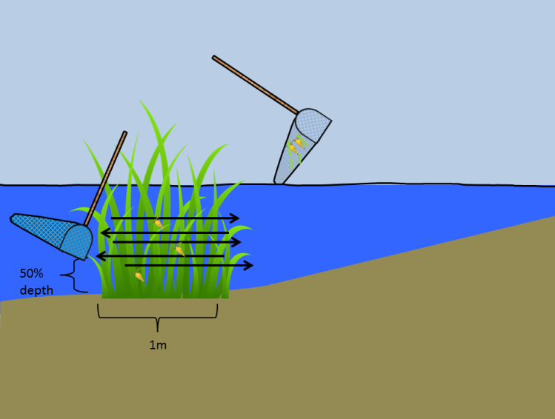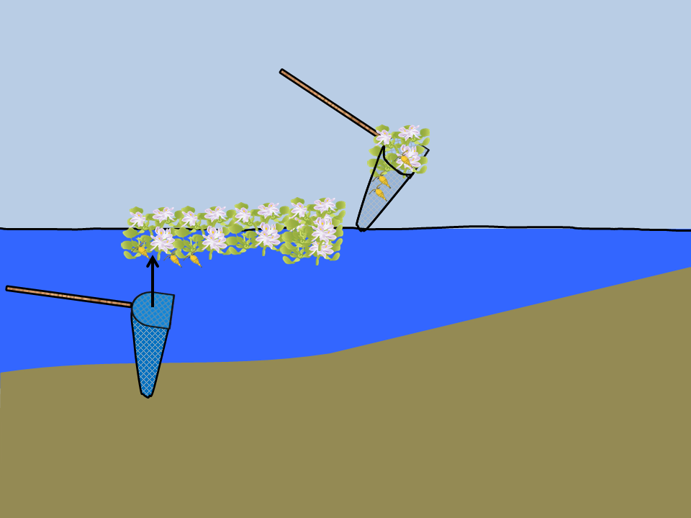

B

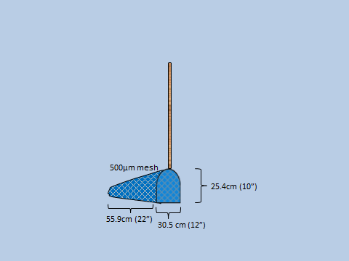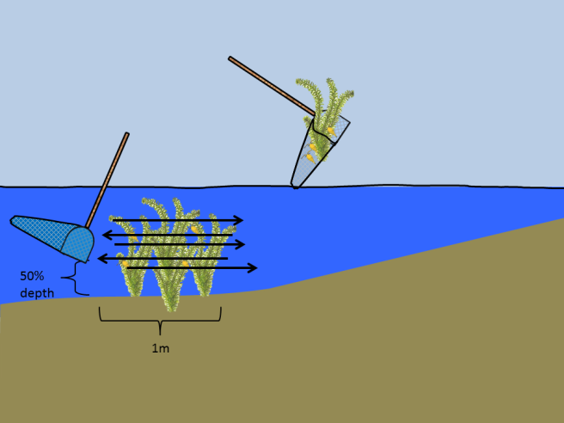

C

D

A

Figure A) Specifications of the sweep net. B) Use of sweep net in emergent vegetation. C) Use of sweep net in submerged vegetation. D) Use of sweep net in floating vegetation.

To allow us to make inferences for broad-scale invertebrate-vegetation relationships, we will take an SAV rake sample immediately after collecting a sweep net sample at each SAV site (see XXXXXXXXXX).

**FAV:**  Sampling techniques in FAV were dependent on FAV species. For *Eichhornia crassipes*, *Hydrocotyle,* and *Azolla*, we harvested a 25cm x 30cm sample from below using the same d-frame net and severing the connection to surrounding plant material with shears (Figure 3C; (Donley Marineau et al. 2017)). We placed the roots of the plant material and associated invertebrates on ice. Upon return from the field, we will separate the invertebrates from the vegetation and dry the plants to a constant weight. *Ludwigia* spp. is a creeping emergent, and does not form discrete, easy-to-harvest clumps. Therefore, it will be sampled with five 1-meter sweeps, as for EAV.

#### Open water and channel

Our open water sampling patches were haphazardly distributed across all unvegetated open water and channels > 1.5m across. Methods used in open-water have a long history of use in monitoring in the Delta, and will allow us to compare our measurements in vegetated wetlands to conditions in channels and make comparisons to long-term data sets. Methods included: zooplankton and mysid trawls, PVC cores and ponar grabs.

**Benthic core:** Benthic cores have been used extensively to quantify bivalves and other infauna in tidal wetlands (Howe et al. 2014; Wells 2015). In shallow water (<1.5m), we took a 4in (20cm) diameter benthic core (Figure 5A), hand-deployed to a depth of 20 cm. In deep water >1.5m, we used a 6x6 in ponar grab modified for use in hard substrates (as per USFWS Liberty Island Monitoring, L. Smith pers. comm, figure 5B), with three samples at each site. The core was washed and sieved on board the boat to remove the sand/mud and preserve any organic detritus and invertebrates. We calculated effort as catch per surface area of substrate sampled.

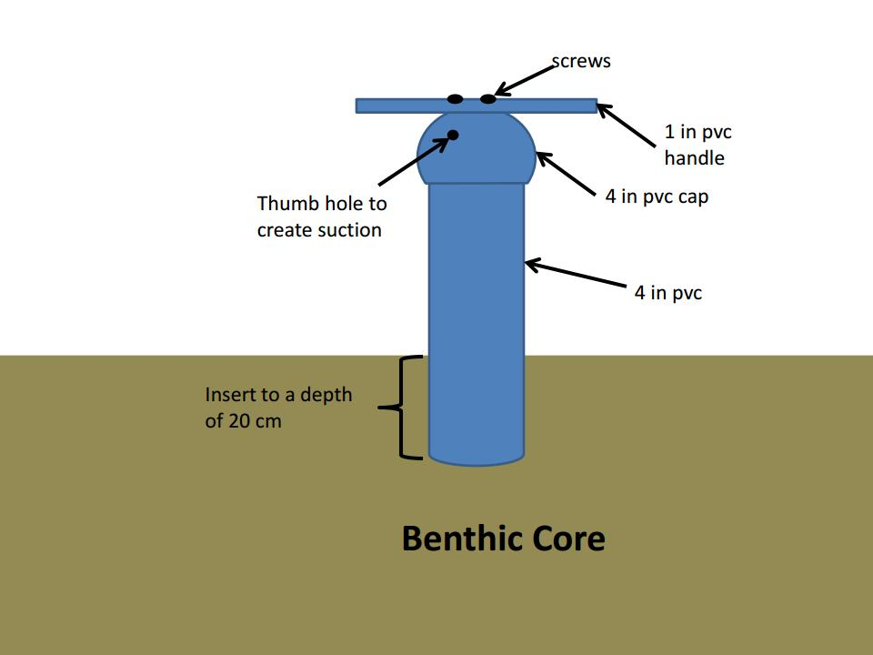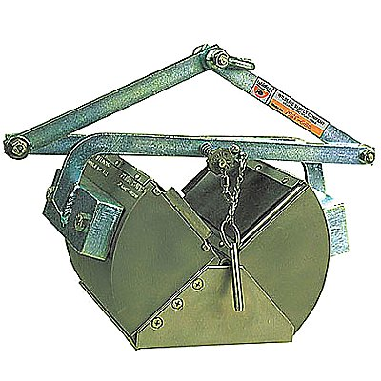

Figure . A) Benthic core made of 4” PVC pipe for use in shallow water (<1.5 meters). B) Ponar grab for use in water greater than 1.5 meters.

**Mysid and zooplankton nets:** Macrozooplankton (Mysid) nets have been used extensively to characterize macrozooplankton in the water column. Macrozooplankton includes amphipods and mysids that are large components of fish diets (Feyrer et al. 2003, Slater and Baxter 2014). We sampled macrozooplankton in the water column using a 50 cm mouth diameter (0.500 mm mesh size) mysid net and sampled mesozooplankton with a 14.6 cm diameter (0.150 mm mesh size) zooplankton net attached or held alongside (similar to EMP methods, (Hennessy 2009)). These nets were held approximately 1 m to the site of the bout, 10 cm below the surface of the water and trawled at 1-2 mph for five minutes. A flowmeter mounted in the net measured sample volume, and effort was standardized by catch per liter of water sampled.

Where channels are less than 1.5 m in width, and no open water is present, we placed the net in the channel on an ebb tide, and allow the tidal current to flow through the net for five minutes instead of trawling the net. After retrieval, the nets were be rinsed from the outside to wash down the sample into the cod end. All content collected in a cod end was preserved in 70% ethanol for identification in the lab.

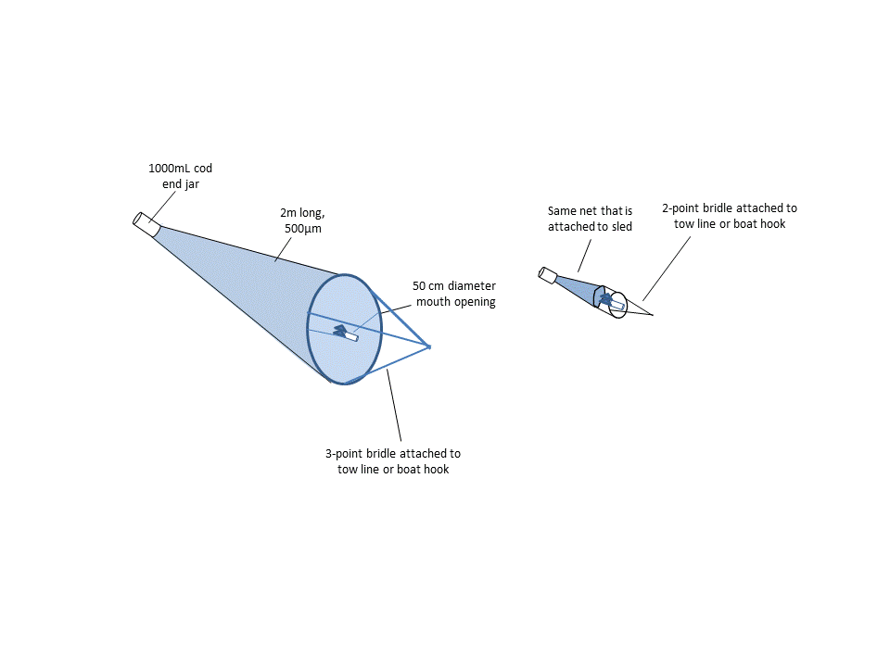

Figure . Set up of mysid and zooplankton nets.

**Neuston tow:** The neuston net is a 45 cm x 30 cm rectangular net, 1m long with 0.500 mm mesh towed half-way out of the water to sample invertebrates on the surface of the water (Figure 7A, B). We towed the neuston net at the surface of the water from the side of the boat via a boat-hook. In very shallow or narrow channels, we pulled the net along the edge of emergent vegetation by hand (Figure 7C; as in (Howe et al. 2014)). We standardized effort by the distance of the tow calculated by GPS track multiplied by half the mouth area of the net to calculate volume of water sampled. After retrieval, all content collected in a cod end was preserved in 70% ethanol for later ID.

**Phytoplankton:** At each zooplankton trawl site, a single, 150 mL sample of water was from the surface and preserved with Lugol’s iodine solution for identification of phytoplankton community composition.

#### Phytoplankton spatial variability

To better differentiate between the sources of phytoplankton in the water column, intensively sampled a wider variety of habitats at one site (Liberty Island). At Liberty, we collected phytoplankton from four microhabitats within the wetland:

1. 4 Submerged vegetation samples – algae was scraped from a 10-cm section of *Egeria densa, Ceratophyllum demersum*, or *Potamogeton crispus*.
2. 4 emergent vegetation samples – algae was scraped from a 10-cm section of *Schoenoplectus* spp.
3. 3 Benthic samples (Epipelic) – algae were rinsed from the mud collected by a petite ponar grab
4. 6 Pelagic – phytoplankton collected from surface water after zooplankton trawl

To answer question 3, we will conduct increased sampling at one site (Decker Island) throughout the spring, approximately every two months (January, March, May, June, August).

Cell counts and community composition were processed by EcoAnalysts.

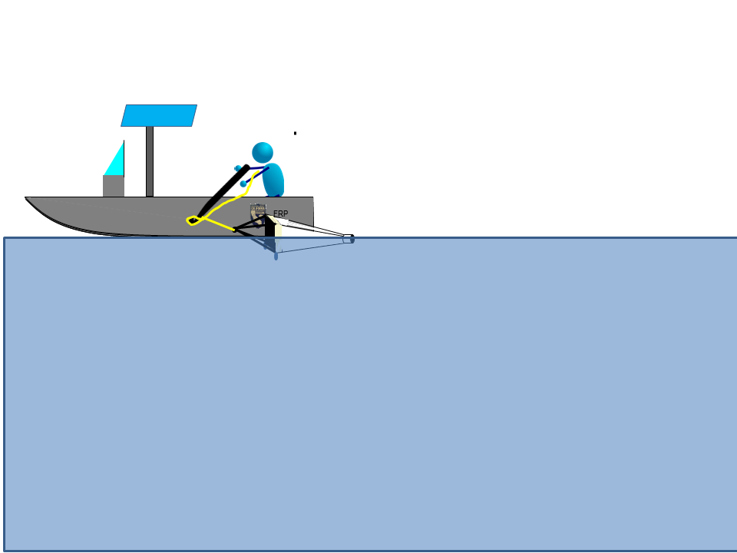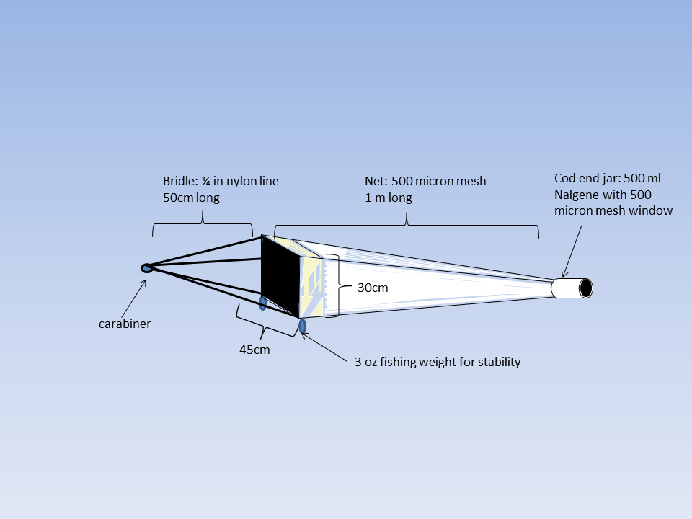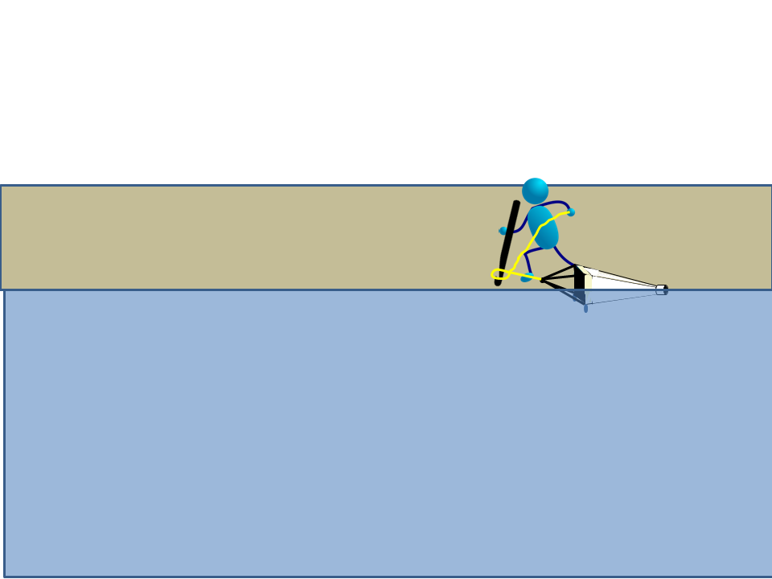

Figure . A) Specifications for the neuston net. B) Deploying the neuston net alongside a boat. C) Deploying the neuston net from shore.

### Laboratory Methods

**Taxonomic effort**: Invertebrates were sorted and identified to taxonomic level according to their importance in fish diets (see Table 3). Mysids, isopods and amphipods were identified to Genus or Species; insects were identified to Family. The first twelve individuals of each taxonomic group per sample will be measured to the nearest 0.1mm using an ocular micrometer. Therefore, all bivalves were identified to genus and measured along the longest axis to the nearest mm.

#### Macroinvertebrates

All trawls and sweepnet samples were sorted to extract macroinvertebrates (> 500 microns) from plant material and detritus. Benthic infauna (most importantly invasive bivalve grazers *Corbicula* and *Potamocorbula*), are not commonly found in salmon or smelt diets; however, the influence of invasive bivalves on the food web makes them important to predicting availability of production to the pelagic food web (Kimmerer and Lougee 2015; Lucas and Thompson 2012). Therefore, all bivalves were extracted from benthic samples and enumerated. All other benthic infauna were marked as “Present” but not counted. Zooplankton caught incidentally in macroinvertebrate samples were marked as “present” but not counted.

Invertebrates were identified by a Senior Laboratory Assistant (SLA) or Scientific Aide. A subset of samples had identifications checked by an Environmental Scientist for quality assurance. Another subset of samples were checked by an outside lab (EcoAnalysts, Inc.), for external quality assurance.

**Subsampling:** Approximately 400 invertebrates from each sample were identified. If more than 400 invertebrates are present in a sample, or more than four hours are required for processing, they were quantitatively sub-sampled using a grid tray.

Table Levels of taxonomic resolution for each group of taxa commonly found in invertebrate samples.

|  |  |  |  |  |
| --- | --- | --- | --- | --- |
| Phylum | Subphylum | Class | Order | Level of ID |
| Annelida |  | all | all | Class |
| Arthropoda | Chelicerata | Arachnida | all | Class |
| Arthropoda | Crustacea | Maxillopoda: Copepoda | all | Genus |
| Arthropoda | Crustacea | Malacostraca | Amphipoda | Genus |
| Arthropoda | Crustacea | Malacostraca | Cumacea | Class |
| Arthropoda | Crustacea | Malacostraca | Decapoda | Species |
| Arthropoda | Crustacea | Malacostraca | Isopoda | Genus |
| Arthropoda | Crustacea | Malacostraca | Mysidea | Species |
| Arthropoda | Crustacea | Branchiopoda | Cladocera | Genus |
| Arthropoda | Crustacea | Ostracoda | Podocopida | Order |
| Anthropoda | Hexapoda | Collembola | All | Class |
| Anthropoda | Hexapoda | Insecta | All | Family |
| Mollusca |  | Bivalvia | All | Genus |
| Mollusca |  | Gastropoda | All | Family |
| Nematoda |  | All | All | Phylum |
| Platyhelminthes |  | All | All | Phylum |

#### Zooplankton

Most zooplankton samples were processed by CDFW staff at the Stockton laboratory, but 50 samples were processed by EcoAnalysts, Inc. (Moscow, ID). Samples were processed in the same manner by both laboratories. First, samples were filtered and washed in a 150 μm mesh sieve. Filtered zooplankton were diluted to a set volume depending on the concentration of zooplankton and/or detritus. One-mL subsamples were then placed on a Sedgewick-Rafter cell glass slide. All organisms were identified to the taxonomic resolution identified in Table 2. At least 5 slides, but no more than 20 slides were processed for each sample, targeting at least 400 organisms. This subsample was then extrapolated to calculate the total number of organisms in the sample. A subset of samples was checked by a second taxonomist for quality assurance.

#### Phytoplankton

All laboratory analysis of algal samples was conducted by EcoAnalysts, Inc. (Moscow, ID), using the Utermöhl microscopic method (Utermöhl 1958) and APHA Standard Methods (APHA 2017). In brief: At least 400 total algal units and 100 units of the dominant taxon or taxa (genus or species level) were counted at appropriate levels of magnification for the cell size. The first 10 units of each major taxon and the first unit of each minor taxon were measured to the nearest micrometer (µm) (1st greatest axial length, 2nd greatest axial length, and 3rd greatest axial length). Final counts were expanded to account for subsampling.

### Analysis

We calculated catch-per-unit-effort (CPUE) for each sample as described above.

To answer Question 1 on the inter-annual variation in macroinvertebrates, we compared samples from 2018 to samples from 2017 and 2016 for sites that were sampled in multiple years. We used mean CPUE to compare biomass and density across sites within years and between years using generalized linear models (GLMs). We tested the fit of all possible models and their first-order interactions using Akaike’s Information Criterion corrected for small sample sizes (AICc) (Anderson 2008, Gotelli and Ellison 2012). Environmental variables may be used as co-variates to explain potential differences in catch between areas, and final models will be presented graphically with standard errors. Since we only have two to three years of data per site, we will not be able to differentiate between variance due to water year type and variance due to other inter-annual factors, however the same analyses can be conducted in future years when we have more data per water year type. This data will also provide the “Before” of our Before-After Control-Impact design.

To answer Questions 2 on the differences between wetland sites, copared, and community composition of samples from our spatially extensive spring sampling event of 2018. These different wetland sites will provide the “Control-Impact” blocks for our BACI design in future analyses. We will analyze the data from the subset of stations with both Spring and Fall sampling by analyzing CPUE of organism found in Delta Smelt diets for the life stage at observed in proximity to the sites.

We will use mean catch, CPUE and BPUE to compare biomass and density across habitat types within sites, among sites, and among regions using generalized linear models (GLMs), with the predictor variables listed in Table 4. We will test the fit of all possible models and their first-order interactions using Akaike’s Information Criterion corrected for small sample sizes (AICc) (Anderson 2008, Gotelli and Ellison 2012). Environmental variables may be used as co-variates to explain potential differences in catch between areas, and final models will be presented graphically with standard errors.

To detect differences in community composition, we will permutational multivariate analysis of variance, non-metric multidimensional scaling, and/or canonical correspondence analysis using the same set of predictor variables.

Table Predictor variables

|  |  |  |
| --- | --- | --- |
| Variable | Variable type | Description |
| Region | Categorical | Region of the estuary as shown on Figure 1 |
| Site type | Categorical | Depth and water management regime (diked wetland, tidal wetland, shallow open water, or channel) |
| Habitat type | Categorical | Depth of water and presence of vegetation (Emergent wetland, SAV, FAV, open-water, or benthic) |
| Site (error term) | Categorical | Identity of wetland site, sued as an error term to prevent pseudoreplication. |

To answer Question 3, we will analyze the four sampling events from Decker Island to see when CPUE and BPUE of fish food invertebrates are maximal. We will test the fit of linear and quadratic equations to see when biomass peaks. Hydrologic variables, such as river stage, degree days, or Delta outflow may be used as covariates, where necessary. We will compare any trends in invertebrate catch to trends in salmon and smelt catch at nearby long-term monitoring stations using Man-Kendall tests or Granger tests to see whether highest fish food availability occurs at the same time as fish presence. This may be repeated for specific fish life stages and size classes of invertebrates as necessary (i.e., Smelt Larvae Survey catch compared to copepod nauplii, DJFMP juvenile Chinook salmon catch compared to amphipods and chironomids). We will use these analyses to make recommendations of timing of macroinvertebrate sampling for long-term monitoring programs. We will also use our comparisons between the spring and fall sampling events to recommend where and to what extent fall sampling should occur.

Data used to answer our questions on timing and replication of samples will also provide pre-project data for evaluating the food web benefits of restoration sites.

1. To answer our first question on the major differences between the phytoplankton communities in the wetland channel versus the exterior channel, we will first categorize the water-column phytoplankton based on their most likely habitat. This will be done be comparing relative abundance of various taxa in the water column at Liberty Island with the abundance of tax on each microhabitat (SAV, EAV, benthic, pelagic). Data from Liberty will be supplemented by literature review on algal growth forms and expert opinion (Tiffany Brown, DWR”s EMP study). We will then compare community composition of phytoplankton in the larger set of wetlands to samples collected by FRP in the exterior channels, or data collected by EMP’s phytoplankton survey. These data will be compared using PerMANOVA or other multivariate methods, as appropriate.
   1. We expect to see significantly different communities exiting the wetlands than in the exterior channel, and differences will be driven by higher abundances of epibenthic and epiphytic taxa in the wetland channels.
   2. Samples from the surface of vegetation and benthic substrates within the wetland will have greater overlap in community composition when compared to tidal channels than with exterior channels.
2. To answer our second question on differences between wetlands, we will compare community composition from channels within diked wetlands and tidal wetlands across the salinity regime. These data will be compared between management regimes using PerMANOVA, and across the salinity gradient using CCA, or other multivariate methods, as appropriate.
3. To answer our third question on seasonal variability, we will compare community composition at Decker Island over time.
   1. We expect to see an increase in the proportion of cyanobacteria in samples of phytoplankton from tidal channels later in the spring/summer, as assessed by a beta regression or permutational MANOVA. This will likely require multiple years of data before it can be shown statistically.

## Results

FMWT caught no Delta Smelt during 2018. EDSM caught 89 Delta Smelt in September and October, most of which were either in the Sacramento Deep Water Ship Channel, or the Lower Sacramento River (table X). This was similar to the distribution in figure X, so our fall sampling proceeded as planned, targeting the Confluence and Cache Slough Complex.

Table . EDSM Delta Smelt catch from September and October, 2018.

|  |  |  |
| --- | --- | --- |
| **EDSM Stratum** | **September** | **October** |
| Lower Sacramento | 17 | 6 |
| Sac DW Ship Channel | 38 | 26 |
| Suisun Marsh | 2 |  |
| **Grand Total** | **57** | **32** |

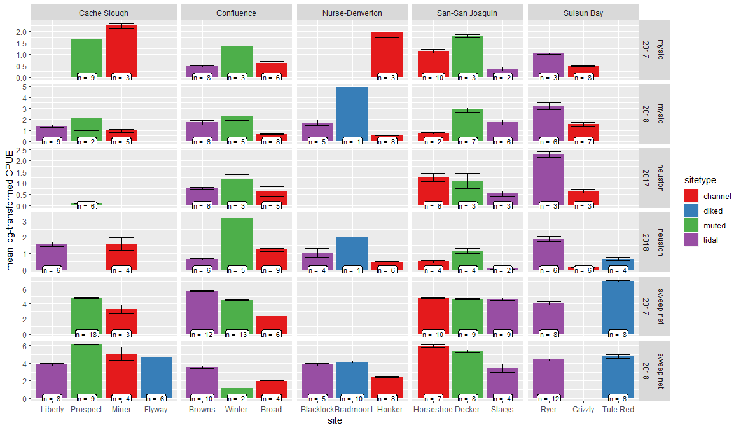

Figure – Log-transformed CPUE of macroinvertebrates collected during the spatially intensive spring sampling events of 2017 and 2018, +/- one standard error. Data are separated by site, year, and gear type.

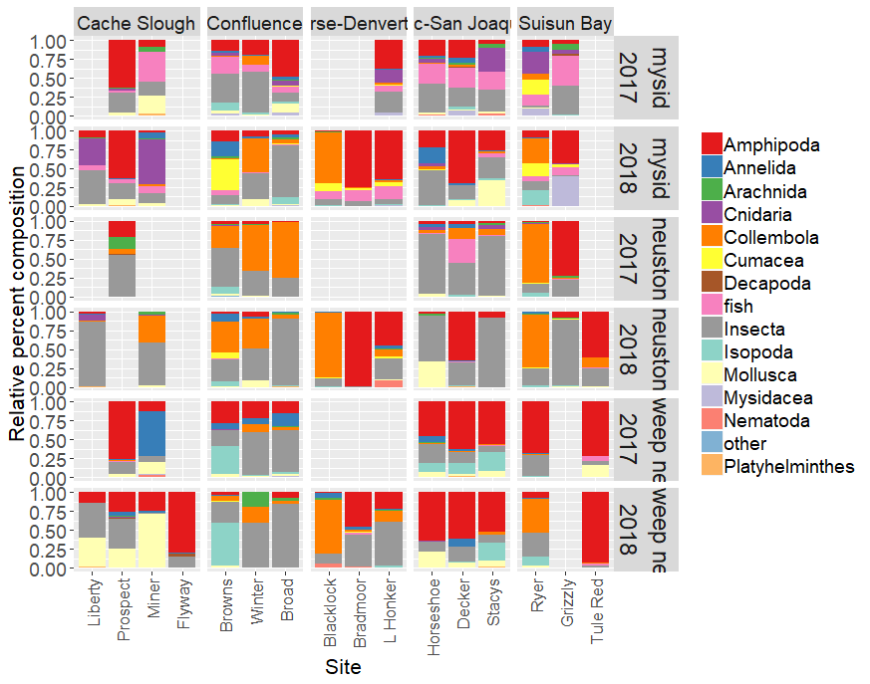

## Discussion

# Chapter 2: Channel-Shoal Gear Comparison

## Introduction

### Nutrients

### Zooplankton

Mesozooplankton are recognized as the largest component of Delta Smelt diets (Slater and Baxter 2014) and a significant component of salmon diets (Sommer et al. 2001). Our conceptual models postulate that tidal wetland restoration sites will have higher production and availability of zooplankton when compared with existing channel habitat and pre-project conditions (Hartman et al. 2017). In order to support this hypothesis, we must compare zooplankton we collect within the wetland to zooplankton collected from the channels. We will leverage existing datasets from long-term monitoring programs currently sampling pelagic and channel habitat whenever possible, but we need a better understanding of how these samples compare to samples taken concurrently from adjacent wetlands. Water depth, substrate, presence of vegetation, presence of benthic grazers (clams), and differences in fish community may alter the zooplankton community (Bollens et al. 2014; Kimmerer and Thompson 2014). Furthermore, changes to the physical environment will affect the efficiency of our sampling gear.

By sampling wetlands concurrently with existing channel sampling, we can characterize some of these sources of variation. During Phase III sampling we conducted sampling of wetland habitat adjacent to eight of the long-term stations sampled by 20mm, however the extremely high water year of 2017 meant that results from that study may not be applicable to all years. Therefore, we repeated our channel-shallow comparisons using stations sampled by either 20mm, FMWT, or the Environmental Monitoring Program (EMP) (see table Table 6). We tested for differences in mesozooplankton, macrozooplankton (mysids), and nutrients between channel habitats in which IEP samples and the shallow littoral habitats in which we sample. This will also give us a better understanding of the spatial variability in zooplankton in wetlands across the estuary.

Mesozooplankton questions:

1. How do mesozooplankton and macrozooplankton communities in the littoral and wetland habitat compare to open water habitat?
2. How do these communities change over the course of the year?
3. How do these communities change along the salinity gradient?

Nutrient questions:

1. Are there differences in nutrients, chlorophyll, and organic carbon concentrations between the wetland and the exterior channel?
2. Are nutrients limiting phytoplankton production?
3. Are excess nutrients a causal factor for harmful algal blooms on our sites?

### Fish

The extent to which at-risk fish species will benefit from tidal wetland restoration in the San Francisco Estuary is unknown (Brown 2003, Herbold et al. 2014). However, restored wetlands in other areas have shown to be productive food sources and provide refuge from predation (Gray et al. 2002, Shreffler et al. 1992, Simenstad et al. 1982). The Fish Restoration Program Monitoring Team was established to monitor the benefits of tidal wetland restoration to at-risk fish species in the San Francisco Estuary. Comparing fish communities and their condition pre- and post-construction can inform how at-risk fish benefit from tidal wetland restoration.

Littoral habitat provides benefits to at-risk fish species, such as salmon, which rear in littoral areas, and Delta Smelt, which inhabit the littoral zone to maintain their position during ebb tides when migrating (McLain and Castillo 2009, Bennett and Burau 2015). However, many of CDFW’s long term monitoring studies sample open water habitat due to gear size, boat size, and absence of vegetation. Sampling littoral and open water habitat simultaneously can provide insights into how fish species utilize different habitats. Similar to the 2017 work plan, the Fish Restoration Program will sample littoral habitat near planned tidal wetlands concurrently with mid-channel sampling by the IEP Summer Townet and Fall Midwater Trawl surveys. For 2018, work will be expanded to tidal wetland reference sites near Ryer and Browns Island.

## Methods

### IEP Surveys

The EMP survey monitors water quality, phytoplankton, meso-/marco-zooplankton, and benthic invertebrates in the upper estuary throughout the year. Zooplankton is collected using a steel sled with paired mesozooplankton (160 μm mesh) and macrozooplankton (500 μm mesh) nets. Phytoplankton is sampled using water collected from submersible pump.

The 20mm Survey monitors Delta Smelt distribution throughout their historical spring range in the Sacramento-San Joaquin Delta and San Francisco Estuary during the spring. The 20mm survey targets Delta Smelt in the post-larval and juvenile life stage, at lengths >20mm. The net is a cone shaped plankton net 5.1 meters in length with an opening circumference of 4.9 meters (1.5 cubic meters). Zooplankton is collected concurrently with a 160 μm mesh modified Clarke-Bumpus net mounted on the frame with its own flowmeter. The survey samples at 40 stations throughout the estuary and completes three 10-minute tows at each station. Zooplankton are only sampled at the first of these tows (Damon, 2015).

The FMWT survey was designed to study Striped Bass distribution throughout the upper estuary, but has since become an integral part of monitoring Delta Smelt and Longfin Smelt distribution and abundance during the fall. Beginning in 2010, meso- and macro-zooplankton sampling was added at 32 of the 122 regular fish sampling sites. Zooplankton is collected after fish trawling is complete, using a same sized EMP steel sled with paired mesozooplankton (160 μm mesh) and macrozooplankton (500 μm mesh) nets. We will sample near five EMP sites, five 20mm sites, two FMWT sites, in adjacent tidal channels or fringing marsh (Table 5, Figure 8), using a paired mysid and zooplankton net as described in Chapter I (Figure 6). These sampling sites were chosen based on their proximity to future FRP restoration sites or comparison wetlands. Thus, we will be able to use these stations to establish a pre-project baseline for zooplankton production, and determine to what extent the effect of restoration is detectable in nearby long-term survey monitoring. Note that while we will discontinue the 2017 macroinvertebrate sampling in Lindsey Slough, we will continue to survey zooplankton alongside 20mm to increase our power to compare data between years.

### FRP Sampling

#### Zooplankton

FRP gear and methods are easily comparable to IEP’s methods. The most important difference is our gear was trawled at the surface of the water for five minutes instead of ten minutes, to reduce potential for take of listed fishes. Where tidal channels or marsh habitat was too short to take a full five-minute tow, the tow time was reduced. In some cases, the gear was held in the mouth of a tidal channel to sample water flowing out of the channel on an ebb tide instead of being trawled.

We sampled monthly from March-June and September - December, in wetlands nearby the long-term surveys as close to the same time as possible. When it was not possible to sample at the same time as the long-term surveys, we sampled the following day at the same point in the tidal cycle.

#### Nutrients

Nutrient sampling methods followed methods used by EMP as closely as possible. At each FRP sampling site, we collected two to three nutrient samples from three different sampling locations:

1. Deep within the wetland as possible, where the water will have the greatest influence from the wetland and least influence from the channel (when possible);
2. At breach/outlet of the site where water is actively moving in or out of the site, or the location of the future breach at pre=restoration sites; and
3. Approximately 100 m outside the site, where we expect some influence of the wetland on water quality in the surrounding channel.

At Tule Red it was infeasible to sample within the wetland on the same date as exterior samples, so only exterior samples were collected.

For each sample we collected two liters of water from just below the surface and transported them back to the lab on ice. We measured chlorophyll florescence from 10 cm below the water’s surface using a YSI 6600 sonde.

In the laboratory, we processed the water as required by DWR’s Bryte laboratory. For dissolved nutrient samples, we filtered 200 mL water using a 0.45 micron nitrocellulose membrane filter and saved the filtrate on ice; for total nutrients, we filled the sample bottle with unfiltered water and placed the sample on ice. We collected one chlorophyll sample per day to calibrate chlorophyll florescence readings. For each chlorophyll sample, we collected one liter of surface water and transported the water to the lab. In the lab, we filtered 500 mL of water onto a GF/F glass fiber filter and froze the sample immediately.

#### Fish

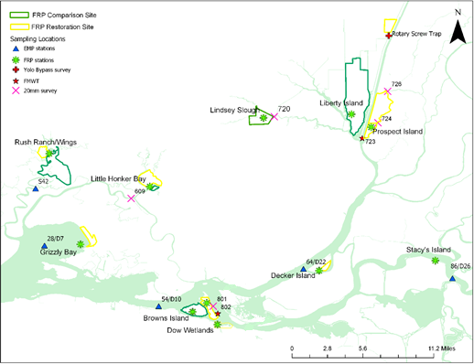

Figure . Zooplankton sampling stations. We will take zooplankton macroinvertebrates, and nutrients samples from shallow wetland habitats (green stars) in proximity to established 20mm sampling sites (pink Xs), established FMWT zooplankton sites (orange shrimp), and EMP sites (blue triangles).

Table . Sample numbers for meso- and macro-zooplankton trawls and nutrient samples taken concurrently with other monitoring programs.

|  |  |  |  |  |  |  |  |  |
| --- | --- | --- | --- | --- | --- | --- | --- | --- |
| Survey | Months | | FRP Site | Long Term Site | Mysid Trawl | Zoop Trawl | Nutrient Water Sample | Total |
| 20mm | March-June | | Little Honker/Blacklock | 609 | 4 | 4 | 24 | 32 |
| 20mm | March-June | | Lindsey Slough | 720 | 4 | 4 | 12 | 20 |
| 20mm | March-June | | Prospect Island | 724 | 4 | 4 | 12 | 20 |
| 20mm | March-June | | Liberty Island | 723 | 4 | 4 | 12 | 20 |
| 20mm | March-June | | Winter, Dow | 801 | 8 | 8 | 24 | 40 |
| FMWT | Sept-Dec | | Prospect, Liberty | 723 | 8 | 8 | 24 | 40 |
| FMWT | Sept-Dec | | Winter, Dow | 802 | 8 | 8 | 24 | 40 |
| EMP | March-Dec | | Grizzly Bay | 28/D7 | 8 | 8 | 16 | 32 |
| EMP | March-Dec | | Rush Ranch/Wings | S42 | 8 | 8 | 24 | 40 |
| EMP | March-Dec | | Decker Island | 64/D22 | 8 | 8 | 24 | 40 |
| EMP | March-Dec | | Stacy’s Island | 86/D26 | 8 | 8 | 24 | 40 |
| EMP | Sept-Dec | | Browns | 54/D10 | 4 | 4 | 12 | 20 |
|  |  |  | |  | 76 | 76 | 232 | 384 |

### Lab methods

Zooplankton will be processed using the same methods as IEP’s 20mm Survey. In brief:

All samples were filtered and washed in a 150 μm mesh sieve. Filtered zooplankton were diluted to a set volume depending on the concentration of zooplankton and/or detritus. 1mL subsamples were placed on a Sedgewick-Rafter cell glass slide. All organisms were identified to the taxonomic resolution identified in Table 3. At least 5 slides, but no more than 20 slides were processed for each sample, targeting 400 organisms. This subsample was then be extrapolated to calculate the total number of organisms in the sample in individuals per cubic meter of water sampled.

All samples were processed by a trained Senior Laboratory Assistant (SLA). A subset of samples had identifications checked by a second SLA or Environmental Scientist for quality assurance.

Macrozooplankton will be processed using the same methods as described in Chapter 1. Because the FMWT survey only enumerates mysids and amphipods in their samples, we will only compare catches of these taxa, and use catch of other taxa for separate analyses of spatial variability.

Nutrient samples are processed at DWR’s Bryte laboratory using standard methods.

### Analysis

To compute biomass per unit effort (BPUE), we will use the average biomass by life stage established for common zooplankton taxa collected by the 20 mm Survey and FMWT survey (Hennessy unpublished data).

To answer question 1 on spatial variability, we will compare CPUE and BPUE from samples collected across habitat types and over the salinity gradient using generalized linear models (GLMs), with predictor variables listed in Table 7. We will test the fit of all possible models and their first-order interactions using AICc (Anderson et al. 2000, Gotelli and Ellison 2012), though we may not be able to incorporate both Collection Group and Habitat type in the same model due to co-linearity. Environmental variables may be used as covariates to explain potential differences in catch between areas.

We will also use analysis of similarities, non-metric multidimensional scaling, and/or canonical correspondence analysis to test differences in community composition between habitat types and across the salinity gradient.

To test differences in nutrients and carbon between the wetland and the channel, we will graph chlorophyll, nutrients, and organic carbon versus sampling location (inside, breach, outside, far outside), over time at each site. A generalized linear model will be attempt compare these values statistically, but it is unlikely any detection will occur with one year of data. To determine whether nutrients are limiting phytoplankton production, we will compare nutrient and chlorophyll concentrations in the wetland to published literature values for nutrient concentrations and ratios in the Delta. A GLM of all the chlorophyll and nitrogen data will be best modeled by a parabolic curve or show a threshold of chlorophyll above which nitrogen decreases. To answer causal factors for algal blooms, we will compare visual reports of *Microcystis* and other cyanobacteria with nitrogen concentrations.

Table . Predictor variables for models of spatial and intra-annual variation in zooplankton catch and biomass

|  |  |  |
| --- | --- | --- |
| Variable | Variable type | Description |
| Julian day | Continuous | Day of year sample was collected |
| Collection group | Categorical | EMP, 20mm survey, FMWT survey, or FRP survey |
| Habitat type | Categorical | Deep channel, tidal channel, or shoals. |
| Distance from GG | Continuous | Distance from the Golden Gate, in Km. |

This work will help us determine the future level of replication necessary to support assessment of restoration project goals. Data used to answer our questions on timing and replication of samples will also provide pre-project data for evaluating the food web benefits of restoration sites.

## Results

## Discussion

# CHAPTER 3: Methods Development

Project Component Lead: Dave Contreras

## Introduction

### ARIS Sonar

Due to procurement issues obtaining an ARIS sonar device this year, we would like to reinitiate a component from the 2017 work plan. Last year, we briefly worked with the USGS observing how fish behave within wetland breach sites using Dual frequency IDentification SONar (DIDSON) and Adaptive Resolution Imaging Sonar (ARIS) devices. We used gill nets and boat electrofishing to confirm species identity, but because we fished within the sonar field-of-view, we were able to observe fish response to the gears (e.g., a few fish appeared swim towards the gill net and then do a u-turn away from the net). We would like to see if an ARIS sonar device can be used to determine how effective electrofishing and gill net sampling techniques are, and whether particular biases of the methods could be identified. Full gear efficiency studies are labor intensive, requiring planning and the recognition of the limitations of the evaluation technique. We propose to explore gear evaluation techniques in 2018 and plan a comprehensive gear efficiency study for gill netting and boat electrofishing for 2019. We will also explore the extent to which an ARIS would be useful in monitoring fish communities in wetland habitats that are difficult to sample with other gears (e.g., adjacent to emergent vegetation).

Fish study questions:

* Can the ARIS sonar be used as a tool to determine gill net and electrofishing efficiency?
* Can ARIS sonar be used to monitor fish use of wetlands with decreased take of listed species?

### SAV methods devlopment

## Methods

### Location and Timing

Sampling will occur from Suisun Bay to the North Delta near existing managed or tidal wetlands, some of which are slated for restoration: Ryer Island, Tule Red, Bradmoor Island, Winter Island, Decker Island, and Prospect Island (Figure 9). Sampling sites were chosen based on the ability to sample effectively and in proximity to established long-term monitoring sites (Figure 9).



- Summer Townet

- Fall Midwater Trawl

- Beach Seine or Lampara Haul

- ARIS & Electrofishing or Gill Net

**Figure 9.** Map of the proposed sampling sites. Four ARIS locations will be selected at each transect.

Sampling will occur from January through December of 2018 (Table 7). All beach seine or lampara sampling will begin in June and end by December to coincide with Summer Townet and Fall Midwater Trawl surveys. ARIS evaluations of the boat electrofisher and gill net will occur from January to June.

**Table 7.** Maximum sample numbers for gear types and sampling period. * denotes long term monitoring gear types.

|  |  |  |
| --- | --- | --- |
| **Gear Types** | **N** | **Sampling Period** |
| Beach Seine (or lampara) | 156 | Jun-Aug |
| Townet* | 42 |
| Beach Seine (or lampara) Midwater Trawl* | 88  36 | Sep-Dec |
| Boat Electrofisher with | 30 | Jan-May |
| ARIS |  |
| Gill Net with | 30 | Apr-Jun |
| ARIS |  |

### Description of Sampling Methods

Data collected with all samples include: date, location, weather, tide stage/water depth, water velocity, surface and bottom specific conductance, surface and bottom water temperature, DO,

### ARIS Evaluation of Boat Electrofisher and Gill Net

An Adaptive Resolution Imaging Sonar (ARIS) will be used to evaluate the efficiency of boat electrofishing and gill net sampling in the vicinity of Decker and Prospect Islands. Four sites will be sampled in both Horseshoe Bend and Miner Slough using the following methods. An ARIS unit will be mounted on the hull of a kayak to record the presence and behavior of fish in a defined sampling area. The kayak will make a slow pass of the sampling site approximately 15m away and record fish presence within the sampling area. Once the site has been recorded with the ARIS, the site will be electrofished. A Smith-Root electrofishing vessel with a 5.0 GPP electrofisher will be used to sample the site following the ARIS recording. Crew members will stand on the bow of the vessel operating a foot pedal, using eight to ten second bursts of electricity along one shoreline. All fish will be collected with a 5mm mesh dip net and placed in a live well, measured, and counted.

To estimate efficiency of gill net sampling, an ARIS unit will be mounted on the gill net vessel. The gill net will measure 30.5m long x 1.8m high and is composed of various mesh panels, where the largest mesh panel is 15.2cm. Gill nets will be set at four sites in both Horseshoe Bend and Miner Slough. Each net will be deployed by a vessel parallel to the shore, anchored by two 8lb weights. As the net is sampling, a slow pass will be made with the ARIS unit along the net face to record fish behavior near the gear. After 60 minutes of sampling, the ARIS unit will be shut off and the gill net retrieved. All fish will be placed in a large bin with water. All ESA-listed fish will be measured. Only 30 fish of other species will be measured; all remaining fish will be counted. In the office, fish counts and length estimates will be made from images captured by the ARIS unit.

### SAV survey techniques

Rake collections

Sonar w/Biobase

## Analysis

The littoral and open water habitat catch-per-unit-effort (CPUE), species composition, and fork lengths will be summarized for each species in a table or graph. Size-frequency distributions will be plotted for common and listed fishes by habitat type. Environmental data will also be summarized by habitat type in a table. The CPUE of fish captured and size frequency distributions between the lampara net, townet, and midwater trawl will be analyzed using an ANOVA or non-parametric equivalent, and Kolmogorov-Smirnov two sample tests. MANOVA, ANOSIM, or other multivariate analyses will be used to test for differences in community composition.

Gear efficiency trials using the block net, sonar, and electrofishing will be qualitatively analyzed. Selection of possible sampling locations, set-up time, and learning how to effectively sample will be the focus of these trials. Data gathered from successful gear efficiency trials can be used during a formal 2019 gear efficiency test.

## Results

## Discussion

# Endangered Species Act Take

The Fish Restoration Program is permitted to incidentally take salmonid and sturgeon ESA-listed species managed by NMFS via their 2009 Biological Opinion on the Long term Operations of the Central Valley Project and State Water Project (confirmed with Brycen Swart of NMFS April 22, 2015 via email). The EMP, 20mm, Summer Townet, and Fall Midwater Trawl Studies have existing ESA take permits for their activities. Tables included in this section show estimated maximum incidental take from FRP monitoring activities in 20172018. Take coverage under IEP is being sought for Delta Smelt only. Other ESA species estimates are listed for informational purposes.

**Table 8.** Take of listed fish species in all FRP sampling. Gears not listed had zero take.

|  |  |  |  |  |  |  |  |  |  |  |  |
| --- | --- | --- | --- | --- | --- | --- | --- | --- | --- | --- | --- |
|  |  | | Listed fish species take | | | | | | | | |
| Gear Type | Total # of samples: | Chinook Salmon | | Steelhead | Delta Smelt (larval) | Delta Smelt (juv) | Delta Smelt (adult) | Longfin Smelt (larval) | Longfin Smelt (juv) | Longfin Smelt (adult) | Green Sturgeon |
| Mysid Trawls |  | 0 | | 0 | 2 | 0 | 0 | 25 | 0 | 0 | 0 |
| Beach Seine |  | 2 (fall-run) | | 0 | 0 | 0 | 0 | 0 | 0 | 0 | 0 |
| Total |  | 2 | | 0 | 2 | 0 | 0 | 25 | 0 | 0 | 0 |

# Data Management and Distribution

Most data will be recorded using paper data sheets developed for our study based on IEP long-term monitoring data sheets.

Data will undergo extensive quality checks and quality assurance before analysis. Field data will be checked for completeness before leaving each station, and each day’s field data sheets will be checked before leaving the field. Any obvious mistakes found during review will be corrected immediately (values outside of what is reasonable, incorrect dates, etc.). Data will be entered into a relational database (Microsoft Access) as soon as reasonably possible, not more than one week after collection. Any notations on the field sheet indicating deviations from the SOP or potential problems with the data will be reviewed and translated into data noted in the database. Data will then be printed and compared against the field data sheets line-by-line to ensure no errors in transcription.

After the data have been checked, we will produce summary statistics, histograms, box plots, or scatter plots to check for outliers and ensure data meets the assumptions of relevant statistical tests.

Data will be stored temporarily on the local CDFW server, backed up once per month. Data will be made publically available as soon as reasonably possible after completion of the project, no later than June 2019. The Access database, as well as flat files in .csv or other non-proprietary format, coupled with metadata and a copy of the final report, will be posted on the CDFW FTP site, and the IEP Tidal Wetlands PWT website. A more robust database using Oracle or SQL Server is currently in development by DWR’s Department of Technology Services, which will be stored on DWR’s server.

## Reports

We will provide a full report to the IEP by June 2019 summarizing all results from this study, in tabular or graphical form, as appropriate, with a full analysis and discussion of results. All Delta Smelt take will be reported to IEP via their on-line reporting system, and all anadromous fish take will be reported to NMFS.

## Publications and Conferences

This project will result in at least one IEP newsletter article, on macroinvertebrate variability, comparisons of zooplankton and fish catch between open water and littoral habitats, and fish gear evaluation techniques. One or more members from the FRP program will also present results at the Bay-Delta Science Conference and/or at the Interagency Ecological Program Annual Workshop.

# References

Anderson, D. R. 2008. Model based inference in the life sciences: a primer on evidence. Springer.

Bennett, W.A. and J.R. Burau. 2015. Riders on the Storm: Selective Tidal Movements Facilitate the Spawning Migration of Threatened Delta Smelt in the San Francisco Estuary. Estuaries and Coasts **38**(3): 826-835.

Baxter, R., L. R. Brown, G. Castillo, L. Conrad, S. Culberson, M. Dekar, F. Feyrer, L. Grimaldo, T. Hunt, J. Kirsch, A. Mueller-Solger, S. Slater, T. Sommer, and K. Souza. 2015. An updated conceptual model for Delta Smelt: our evolving understanding of an estuarine fish. Interagency Ecological Program. Sacramento, CA.

Bollens, S. M., J. Breckenridge, J. R. Cordell, C. Simenstad, and O. Kalata. 2014. Zooplankton of tidal marsh channels in relation to environmental variables in the upper San Francisco Estuary. Aquatic Biology **21**:205-219.

Brown, L. R. 2003. Will tidal wetland restoration enhance populations of native fishes? San Francisco Estuary and Watershed Science 1(1):43 pages.

Contreras, D., R. Hartman, S. Sherman, A. Furler, and A. Low. 2016. Pilot study phase I: Results from 2015 gear methodology trials in the North Delta. California Department of Fish and Wildlife, Fish Restoration Program, Stockton, CA. Available online: <http://www.water.ca.gov/environmentalservices/docs/frpa/frp_monitoring_pilot_phase_I_final_report.pdf>

Contreras, D., R. Hartman, S. Sherman, and A. Low. 2017. Pilot Study Phase II: Results from 2016 gear evaluation in the North Delta. California Department of Fish and Wildlife, Fish Restoration Program, Stockton, CA.

(CDFW) California Department of Fish and Wildlife (2009). California Endangered Species Act Incidental Take Permit No. 2081-001-03 on Department of Water Resources California State Water Project Delta Facilities and Operations. Sacramento, CA.

Damon, L. 2015. [Memorandum: 2015 Index of Delta Smelt Abundance from the 20-mm Survey](https://nrm.dfg.ca.gov/FileHandler.ashx?DocumentId=103301) , California Department of Fish and Wildlife. Stockton, CA.

David, A. T., C. A. Simenstad, J. R. Cordell, J. D. Toft, C. S. Ellings, A. Gray, and H. B. Berge. 2016. Wetland loss, juvenile salmon foraging performance, and density dependence in Pacific Northwest estuaries. Estuaries and Coasts **39**:767-780.

Ferrari, M. C. O., L. Ranaker, K. L. Weinersmith, M. J. Young, A. Sih, and J. L. Conrad. 2014. Effects of turbidity and an invasive waterweed on predation by introduced largemouth bass. Environmental Biology of Fishes **97**:79-90.

Feyrer, F., B. Herbold, et al. 2003. Dietary shifts in a stressed fish assemblage: Consequences of a bivalve invasion in the San Francisco Estuary. Environmental Biology of Fishes **67**(3): 277-288.

Gotelli, N. and A. Ellison. 2012. A Primer of Ecological Statistics. 2 edition. Sinauer Associates, Inc.

Goertler, P., K. Jones, J. Kirsch, L. Conrad, and T. Sommer. (In review). Chinook Salmon Tidal Wetlands Conceptual Modal. Chapter 8. in S. Sherman, R. Hartman, and D. Contreras, editors. *Effects of tidal wetland restoration on fish: a suite of conceptual models.* IEP Technical Report xx. Department of Water Resources, Sacramento, California.

Gray, A., C. A. Simenstad, D. L. Bottom, and T. J. Cornwell. 2002. Contrasting functional performance of juvenile salmon habitat in recovering wetlands of the Salmon River estuary, Oregon, U.S.A. Restoration Ecology **10**:514-526.

Hartman, R. and S. Sherman. In review. Tidal Wetlands Overview Conceptual Model. Chapter 1. in S. Sherman, R. Hartman, and D. Contreras, editors. *Effects of tidal wetland restoration on fish: a suite of conceptual models.* IEP Technical Report xx. Department of Water Resources, Sacramento, California.

Hartman, R. L. Brown, and J. Hobbs In review. Food Web Conceptual Model. Chapter 5. in S. Sherman, R. Hartman, and D. Contreras, editors. *Effects of tidal wetland restoration on fish: a suite of conceptual models.* IEP Technical Report xx. Department of Water Resources, Sacramento, California.

Hennessy, A. 2009. Zooplankton Meta Data. IEP Bay-Delta Monitoring and Analysis Section, Department of Water Resources, Sacramento, CA.

Herbold, B., D.M. Baltz, L. Brown, R. Grossinger, W. Kimmerer, C.S. Simenstad, C. Wilcox, M. Nobriga. 2014. The Role of Tidal Marsh Restoration in Fish Management in the San Francisco Estuary. San Francisco Estuary and Watershed Science 12(1):6pp.

Howe, E. R., C. A. Simenstad, et al. (2014). "Macroinvertebrate Prey Availability and Fish Diet Selectivity in Relation to Environmental Variables in Natural and Restoring North San Francisco Bay Tidal Marsh Channels." San Francisco Estuary and Watershed Science **12**(1).

Kimmerer, W. J., J. R. Burau, and W. A. Bennett. 1998. Tidally oriented vertical migration and position maintenance of zooplankton in a temperate estuary. Limnology & Oceanography 43(7):1697-1709.

Kimmerer, W. J. 2002. Effects of freshwater flow on abundance of estuarine organisms: physical effects or trophic linkages? Marine Ecology Progress Series 243:39-55.

Kimmerer, W. J., E. S. Gross, and M. L. MacWilliams. 2014. Tidal migration and retention of estuarine zooplankton investigated using a particle-tracking model. Limnol. Oceanogr. **59**:901-916.

Kimmerer, W. J. and L. Lougee. 2015. Bivalve grazing causes substantial mortality to an estuarine copepod population. Journal of Experimental Marine Biology and Ecology **473**:53-63.

Lucas, L. V. and J. K. Thompson. 2012. Changing restoration rules: Exotic bivalves interact with residence time and depth to control phytoplankton productivity. Ecosphere **3**:art117.

Maier, G. O., and C. A. Simenstad. 2009. The role of marsh-derived macrodetritus to the food webs of juvenile Chinook salmon in a large altered estuary. Estuaries and Coasts 32(5):984-998.

McLain, J., G. Castillo. (2009). Nearshore Areas Used by Fry Chinook Salmon, Oncorhynchus tshawytscha, in the Northwestern Sacramento–San Joaquin Delta, California.San Francisco Estuary and Watershed Science*,* 7(2): 12pp.

(NMFS) National Marine Fisheries Service (2009). Biological Opinion and Conference Opinion on the long-term operations of the Central Valley Project and the State Water Project. N. M. F. Service. Long Beach, California**:** 844 pages.

Rozas, L. and W. Odum. 1988. Occupation of submerged aquatic vegetation by fishes: testing the roles of food and refuge. Oecologia **77**:101-106.

Scatolini, S. R. and J. B. Zedler (1996). Epibenthic invertebrates of natural and constructed marshes of San Diego Bay. Wetlands 16(1): 24-37.

Shreffler, D.K., C.A. Simenstad, R.M. Thom. 1992. Foraging by Juvenile Salmon in a Restored Estuarine Wetland. Estuaries 15(2): 204-213.

Simenstad, C.A., K.L. Fresh, E.O. Salo. 1982. The Role of Puget Sound and Washington Coastal Estuaries in the Life History of Pacific Salmon: An Unappreciated Function. Estuarine Comparisons , p. 343-364. In V. S. Kennedy (ed.), Estuarine Comparisons. Academic Press, New York.

Simenstad, C. A. and J. R. Cordell (2000). Ecological assessment criteria for restoring anadromous salmonid habitat in Pacific Northwest estuaries. Ecological Engineering **15**(3–4): 283-302.

Slater, S. B. and R. D. Baxter. 2014. Diet, prey selection and body condition of age-0 Delta Smelt, *Hypomesus transpacificus*, in the upper San Francisco Estuary. San Francisco Estuary and Watershed Science **14**.

Sommer, T. R., M. L. Nobriga, W. C. Harrell, W. Batham, and W. J. Kimmerer. 2001. Floodplain rearing of juvenile chinook salmon: Evidence of enhanced growth and survival. Canadian Journal of Fisheries and Aquatic Sciences **58**:325-333.

Sommer, T., and F. Mejia. 2013. A place to call home: a synthesis of Delta Smelt habitat in the upper San Francisco Estuary. San Francisco Estuary and Watershed Science 11(2):25 pages.

Turner, A. M. and J. C. Trexler (1997). "Sampling aquatic invertebrates from marshes: evaluating the options." Journal of the North American Benthological Society: 694-709.

(USFWS) United States Fish and Wildlife Service (2008). Formal Endangered Species Act Consultation on the Proposed Coordinated Operations of the Central Valley Project (CVP) and State Water Project (SWP). United States Fish and Wildlife Service. Sacramento, California, United States Fish and Wildlife Service. **81420-2008-F-1481-5:** 396 pages.

Wells, E. 2015. IEP Environmental Monitoring Program Benthos Metadata. C. D. o. W. Resources, editor. Division of Environmental Services, Bay-Delta Monitoring and Analysis Section, West Sacramento, CA.

Whitley, S. N. and S. M. Bollens. 2014. Fish assemblages across a vegetation gradient in a restoring tidal freshwater wetland: diets and potential for resource competition. Environmental Biology of Fishes **97**:659-674.

Williams, J. G. 2012. Juvenile Chinook Salmon (*Oncorhynchus tshawytscha*) in and Around the San Francisco Estuary. San Francisco Estuary and Watershed Science 10(3).

American Public Health Association (APHA). 2017. Standard methods for the examination of water and wastewater, 23 edition. American Public Health Association, American Water Works Association, and Water Environment Federation.

Baxter, R., L. R. Brown, G. Castillo, L. Conrad, S. Culberson, M. Dekar, F. Feyrer, L. Grimaldo, T. Hunt, J. Kirsch, A. Mueller-Solger, S. Slater, T. Sommer, and K. Souza. 2015. An updated conceptual model for Delta Smelt: our evolving understanding of an estuarine fish. Interagency Ecological Program Sacramento, CA.

Bollens, S. M., J. Breckenridge, J. R. Cordell, C. Simenstad, and O. Kalata. 2014. Zooplankton of tidal marsh channels in relation to environmental variables in the upper San Francisco Estuary. Aquatic Biology 21:205-219.

Bottom, D. L., and coauthors. 2011. Estuarine habitat and juvenile salmon: current and historical linkages in the Lower Columbia River and Estuary. Northwest Fisheries Science Center, U.S. National Marine Fisheries Service, National Oceanic and Atmospheric Administration, Seattle, WA.

Bouley, P., and W. J. Kimmerer. 2006. Ecology of a highly abundant, introduced cyclopoid copepod in a temperate estuary. Marine Ecology Progress Series 324:219-228. <Go to ISI>://PREV200700031243.

Brown, L. R., and coauthors. 2014. Synthesis of studies in the fall low salinity zone of the San Francisco Estuary, September-December 2011. U.S. Department of the Interior, U.S. Geological Survey, Sacramento, CA.

Canuel, E. A., J. E. Cloern, D. B. Ringelberg, J. B. Guckert, and G. H. Rau. 1995. Molecular and Isotopic Tracers Used to Examine Sources of Organic Matter and its Incorporation Into the Food Webs of San Francisco Bay. Limnology and Oceanography 40(1):67-81. <http://www.jstor.org/stable/2838250>.

Cloern, J. E., and R. Dufford. 2005. Phytoplankton community ecology: principles applied in San Francisco Bay. Marine Ecology Progress Series 285:11-28. <Go to ISI>://PREV200500194084.

Contreras, D., R. Hartman, and S. Sherman. 2017. Pilot Study Phase II: Results from 2016 gear evaluation in the North Delta. California Department of Fish and Wildlife, Fish Restoration Program, Stockton, CA. <http://www.water.ca.gov/environmentalservices/docs/frpa/pilot_phase_II_report_FINAL_3MAY2017.pdf>.

Contreras, D., R. Hartman, and S. Sherman. 2018. Sampling fish and invertebrate resources in tidal wetlands of the Sacramento-San Joaquin Delta: Report on Phase III Pilot Monitoring, 2017. California Department of Fish and Wildlife, Stockton, CA.

Contreras, D., R. Hartman, S. Sherman, A. Furler, and A. Low. 2016. Pilot study phase I: Results from 2015 gear methodology trials in the North Delta. California Department of FIsh and Wildlife, Fish Restoration Program, Stockton, CA.

David, A. T., P. A. L. Goertler, S. H. Munsch, B. R. Jones, C. A. Simenstad, J. D. Toft, J. R. Cordell, E. R. Howe, A. Gray, M. P. Hannam, W. Matsubu, and E. E. Morgan. 2016. Influences of Natural and Anthropogenic Factors and Tidal Restoration on Terrestrial Arthropod Assemblages in West Coast North American Estuarine Wetlands. Estuaries and Coasts 39(5):1491-1504. <https://doi.org/10.1007/s12237-016-0091-3>.

Donley Marineau, E., M. J. Perryman, J. Hernandez, and S. Lawler. 2017. Are there non-target impacts of invasive water hyacinth management for aquatic invertebrate communities in the Sacramento-San Joaquin River Delta? Ch. 3 in Aquatic Invertebrate Dynamics in Two Systems of Concervation Concern. University of California, Davis, Davis, CA.

Grimaldo, L., F. Feyrer, J. Burns, and D. Maniscalco. 2017. Sampling Uncharted Waters: Examining Rearing Habitat of Larval Longfin Smelt (*Spirinchus thaleichthys*) in the Upper San Francisco Estuary. Estuaries and Coasts:1-14.

Hartman, R., L. Brown, and J. Hobbs. 2017. Food Web Conceptual Model. S. Sherman, R. Hartman, and D. Contreras, editors. Effects of Tidal Wetland Restoration on Fish: A Suite of Conceptual Models, Interagency Ecological Program Technical Report 91. Department of Water Resources, Sacramento, CA.

Hennessy, A. 2009. Zooplankton Meta Data. IEP Bay-Delta Monitoring and Analysis Section, Department of Water Resources, Sacramento, CA.

Howe, E. R., C. A. Simenstad, J. D. Toft, J. R. Cordell, and S. M. Bollens. 2014. Macroinvertebrate prey availability and fish diet selectivity in relation to environmental variables in natural and restoring North San Francisco Bay tidal marsh channels. San Francisco Estuary and Watershed Science 12(1). <http://www.escholarship.org/uc/item/0p01q99s>.

Jassby, A. 2008. Phytoplankton in the upper San Francisco Estuary: recent biomass trends, their causes and their trophic significance. San Francisco Estuary and Watershed Science 6(1):24 pages.

Kimmerer, W. J., and L. Lougee. 2015. Bivalve grazing causes substantial mortality to an estuarine copepod population. Journal of Experimental Marine Biology and Ecology 473:53-63. <http://www.sciencedirect.com/science/article/pii/S0022098115300022>.

Kimmerer, W. J., and J. K. Thompson. 2014. Phytoplankton growth balanced by clam and zooplankton grazing and net transport into the low-salinity zone of the San Francisco Estuary. Estuaries and Coasts:1-17.

Lucas, L. V., and J. K. Thompson. 2012. Changing restoration rules: Exotic bivalves interact with residence time and depth to control phytoplankton productivity. Ecosphere 3(12):art117. <http://dx.doi.org/10.1890/ES12-00251.1>.

Maier, G. O., and C. A. Simenstad. 2009. The role of marsh-derived macrodetritus to the food webs of juvenile Chinook salmon in a large altered estuary. Estuaries and Coasts 32(5):984-998.

Orsi, J. J. 1995. Food habits of several abundant zooplankton species in the Sacramento-San Joaquin estuary. Interagency Ecological Program for the Sacramento-San Joaquin Estuary (IEP), Stockton, CA.

Schroeter, R. E., T. A. O'Rear, M. J. Young, and P. B. Moyle. 2015. The aquatic trophic ecology of Suisun Marsh, San Francisco Estuary, California, during autumn in a wet year. San Francisco Estuary and Watershed Science 13(3). <http://www.escholarship.org/uc/item/3w96c3dt>.

Sherman, S., R. Hartman, and D. Contreras, editors. 2017. Effects of Tidal Wetland Restoration on Fish: A Suite of Conceptual Models. Department of Water Resources, Sacramento, CA.

Slater, S. B., and R. D. Baxter. 2014. Diet, prey selection and body condition of age-0 Delta Smelt, *Hypomesus transpacificus*, in the upper San Francisco Estuary. San Francisco Estuary and Watershed Science 14(4).

Sobczak, W. V., J. E. Cloern, A. D. Jassby, B. E. Cole, T. S. Schraga, and A. Arnsberg. 2005. Detritus fuels ecosystem metabolism but not metazoan food webs in San Francisco Estuary's freshwater Delta. Estuaries 28(1):122-135.

Sobczak, W. V., J. E. Cloern, A. D. Jassby, and A. B. Muller-Solger. 2002. Bioavailability of organic matter in a highly disturbed estuary: The role of detrital and algal resources. Proceedings of the National Academy of Sciences 99(12):8101-8105.

Sommer, T., and F. Mejia. 2013. A place to call home: a synthesis of Delta Smelt habitat in the upper San Francisco Estuary. San Francisco Estuary and Watershed Science 11(2):25 pages.

Sommer, T., K. Reece, F. Mejia, and M. Nobriga. 2009. Delta smelt life-history contingents: a possible upstream rearing strategy. IEP Newsletter 22(1):11-13.

Sommer, T. R., M. L. Nobriga, W. C. Harrell, W. Batham, and W. J. Kimmerer. 2001. Floodplain rearing of juvenile chinook salmon: Evidence of enhanced growth and survival. Canadian Journal of Fisheries and Aquatic Sciences 58(2):325-333.

Turner, A. M., and J. C. Trexler. 1997. Sampling aquatic invertebrates from marshes: evaluating the options. Journal of the North American Benthological Society 16(3):694-709.

Utermöhl, H. 1958. Methods of collecting plankton for various purposes are discussed. SIL Communications, 1953-1996 9(1):1-38. <https://doi.org/10.1080/05384680.1958.11904091>.

Wells, E. 2015. IEP Environmental Monitoring Program Benthos Metadata. C. D. o. W. Resources, editor. Division of Environmental Services, Bay-Delta Monitoring and Analysis Section, West Sacramento, CA. <http://www.water.ca.gov/bdma/meta/benthic.cfm>.

Whitley, S. N., and S. M. Bollens. 2014. Fish assemblages across a vegetation gradient in a restoring tidal freshwater wetland: diets and potential for resource competition. Environmental Biology of Fishes 97(6):659-674. <http://search.proquest.com/docview/1518010595?accountid=147320>.

Williams, J. G. 2012. Juvenile Chinook Salmon (Oncorhynchus tshawytscha) in and Around the San Francisco Estuary. San Francisco Estuary and Watershed Science 10(3). <http://www.escholarship.org/uc/item/96f2t9xw>.